***PROJECT TITLE***

***NUML TRANSPORT MANAGEMENT SYSTEM***

***PROJECT DATE***

*14 DEC 2021*

# PROJECT MEMBER

1. JUNAID UL HASSAN
2. AHAD ALI ZAFAR
3. HAMZA MEHMOOD
4. ANIQUE KHADIM
5. JABRAN NAEEM

# DESCRIPTION

Our execution strategy incorporation proven mythologies, extremely qualify personnel, and a highly responsive approach to managing deliverable. Following is a description of our project, include how project will be developed, a propose timeline of events and reasons for why we suggest develop the projects.

# HOW WE WORK

The following graph show our project **NUML TRANSPORT MANAGEMANT SYSTEM** software developed process. We develop our software by the rule of SDLC

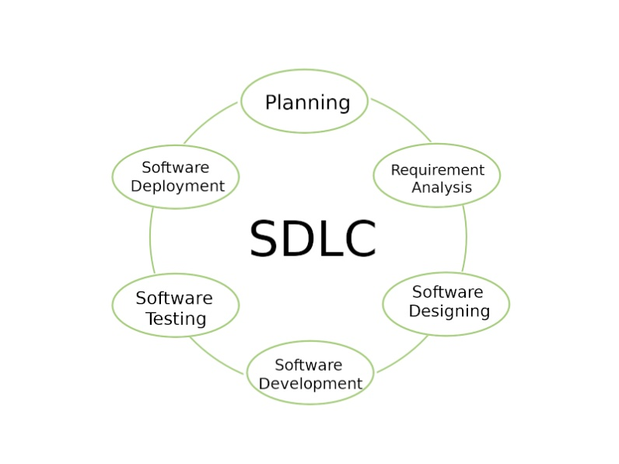

1. The provider will assign a lead consultant to oversee the engagement and serve as a single point for engagement communication.
2. The proven in NUML TMS software developers, system/hardware, engineers, and other IT specials as the requirements and needs.
3. We also resolve the IT issues and make recommendations regarding IT networks, IT security, software, and other data and integration.

# OUR **NUML TMS** SOFTWARE MODULE CONSIST OF

1. Load and optimization
2. Route planning and optimization
3. Delivery
4. Payment and fee challan
5. Yard administration
6. Login on student system id
7. Carrier administration
8. Software security

# GOALS

* Minimize the expenditure by mean of more effective rout planning, load optimization, carrier combination as well as mode selection.
* Enhance accountability with exposure to the transportation chain.
* Better flexibility
* Realization of important supply chain execution demands

# MAIN MODULES

* Web development
* Online registration
* Online payment through bank or credit card
* Payment on cash
* Timetable of routes morning and evening session
* Account management system
* Expire registration
* Student management portal
* Print tickets
* Routes managements
* Detail information about registration
* Settings about security and registration
* Recover forget password through email

# MAIN FEATUERS

* Bar code scanning
* Credit card processing
* Student history
* Customize GUI
* Discounts
* Exchanges
* Layaway and quotes
* Mobile POS capability
* Receipts notes

# BENEFITS TO NUML

1. It simplifies the accounting process, old fashioned cash registers force accountant to short through hundreds of receipts.
2. It simplifies the manage the lots of student’s problems.
3. It is easy to look up past transactions
4. Student can register and can see the location of the bus at any place and student can purchase their own order.
5. Modern worker is often more comfortable with point of sale device than old fashion cash register.
6. The generation now entering the workforce never knew a time without computers, and a result they are very comfortable working with the computerized technology like points of sales devices.
7. It provides faster service than old fashioned cash registers.
8. Students receive more informative receipt points of sales device.
9. Student can save his record on their mobile about registration and print fee challan
10. If any problem produces during the traveling then deriver can inform to the main office through his mobile application software.